**“FRICTION STIR SPOT WELDING OF DISSIMILAR METALS AND DISSIMILAR THIKNESSES**

***K. PRANAY TEJA***

***19951A0337***

**FRICTION STIR SPOT WELDING OF DISSIMILAR METALS AND DISSIMILAR THIKNESSES**



***A Project Report submitted in partial fulfilment of the requirements for the award of the degree of***

**Bachelor of Technology in Mechanical Engineering**

**by**

## K. Pranay Teja

## (19951A0337)

**Under the Guidance of**

**Mr. C. Labesh Kumar**

**Assistant Professor**

**Department of Mechanical Engineering**

INSTITUTE OF AERONAUTICAL ENGINEERING

## (Autonomous)

**Dundigal, Hyderabad - 500 043, Telangana**

## May, 2023

INSTITUTE OF AERONAUTICAL ENGINEERING

## (Autonomous)

**Dundigal, Hyderabad - 500 043, Telangana**

## May, 2023

## DECLARATION

## I certify that:

1. The work contained in this report is original and has been done by me under the guidance of my supervisor(s).
2. The work has not been submitted to any other Institute for any degree or diploma.
3. I have followed the guidelines provided by the Institute in preparing the report.
4. I have conformed to the norms and guidelines given in the Ethical Code of Conduct of the Institute.
5. Whenever I have used materials (data, theoretical analysis, figures, and text) from other sources, I have given due credit to them by citing them in the text of the report and giving their details in the references. Further, I have taken permission from the copy right owners of the sources, whenever necessary.

### Place: Signature of the Students

**Date: Roll No’s: 19951A0337**

## CERTIFICATE

This is to certify that the project report entitled **FRICTION STIR SPOT WELDING OF DISSIMILAR METALS AND DISSIMILAR THIKNESSES** submitted by **K. PRANAY TEJA**, to the Institute of Aeronautical Engineering, Hyderabad in partial fulfillment of the requirements for the award of the Degree Bachelor of Technology in Department of Mechanical Engineering is a bonafide record of work carried out by them under our guidance and supervision.

The contents of this report, in full or in parts, have not been submitted to any other Institute for the award of any Degree.

### Supervisor Head of Department

**Mr. C. Labesh Kumar Dr. V.V.S.H. Prasad**

### Assistant Professor Professor & Head

Date:

**APPROVAL SHEET**

This project report entitled **FRICTION STIR SPOT WELDING OF DISSIMILAR METALS AND DISSIMILAR THIKNESSES** by **K. PRANAY TEJA** was approved for the award of the degree of **Bachelor of Technology** in the **Department of** **Mechanical Engineering.**

### 

### Examiner Supervisor

### Mr. C. Labesh Kumar

### Principal

**Dr. L V Narasimha Prasad**

**Date:**

**Place:**

## ACKNOWLEDGEMENT

The completion of any task of this project would be incomplete and impossible without mentioning those who have spared their valuable time providing right guidance and encouragement.

Therefore, I am humbly grateful and delighted to express my sincere thanks to the following:

1. **Mr. C. Labesh Kumar** – My project guide and Assistant Professor of Mechanical Engineering, for his constant encouragement and valuable guidance throughout the project work.
2. **Dr. V.V.S.H. Prasad** - Head of the Department of Mechanical Engineering for his deep gratitude and encouragement to helping me accomplish this project report to a successful end.
3. **Dr. L. V. Narasimha Prasad** - Our Principal and Professor, who has ignited and helped me realize my hidden potential, inculcate confidence, sincerity and discipline.

## ABSTRACT

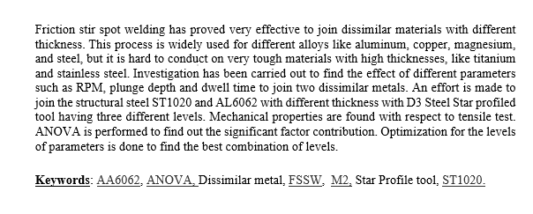

LIST OF CONENTS

|  |  |
| --- | --- |
| Cover Page | 1 |
| Inside Cover Page | 2 |
| Declaration | 3 |
| Certification | 4 |
| Approval Sheet | 5 |
| Acknowledgement | 6 |
| Abstract | 7 |
| List of Contents | 8 |
| List of Figures  List of Tables | 9  10 |
|  |  |

CHAPTER 1: INTRODUCTION……………………………………….…11

1.1 Introduction…………………………………………………………..11

1.2 Operational Principle 12

1.3 Process Parameters 14

1.4 Objective………………………………………………………..….15

1.5 Scope of FSSW…………………………………………….….…...16

1.6 Exiting Method……………………………………………….…....16

CHAPTER 2: LITERATURE SURVEY 20

CHAPTER 3: MATERIALS AND METHODOLOGY 23

3.1 ALUMINUM 6062 23

3.2 Structural steel ST1020………………………………………………24

3.3 D3 steel….…………………………………………………………...24

3.4 Methodology……………...……………………………………….....26

3.5 Welding Method……………………………………………………..26

3.6 Process Parameters…………………………………………………..27

CHAPTER 4: DESIGN AND ANALYSIS.…………………………………..28

4.1 Tool Design………………………………………………………….28

4.2 Heat Treatment……………………………………………………....29

CHAPTER 5: EXPERIMENTAL SETUP………………………………........34

CHAPTER 6: RESULT AND DISCUSSION………………………………...39

CHAPTER 7: CONCLUSION………………………………………………..45

CHAPTER 8: APPLICATIONS……………………………………………..46

References 47

IX

## LIST OF FIGURES

|  |  |  |
| --- | --- | --- |
| **S.No** | **Title** | **Page** |
| Fig 1.1 | Plunging operation | 12 |
| Fig 1.2 | Stirring | 13 |
| Fig 1.3 | Retracting | 13 |
| Fig 1.4 | Steps involved in friction stir spot welding | 14 |
| Fig 1.5 | A schematic of a plunge type FSSW | 17 |
| Fig 1.6 | Schematic of refill FSSW process | 17 |
| Fig 1.7 | Schematic of stitch FSSW | 18 |
| Fig 1.8 | Schematic of swing FSSW | 19 |
| Fig 1.9 | Prototype swing FSSW gun “Swing-Stir” | 19 |
| Fig 3.1 | (a) Lap position of work material, (b) FSSW tool geometry, (c) Setup on machine with fixture | 25 |
| Fig 3.4 | Lap joint of AL6062 and ST1020 | 26 |
| Fig 4.1 | Tool design in SOLIDWORKS 2021 | 28 |
| Fig 4.2 | Muffle Furnace | 30 |
| Fig 4.3 | Tool under Heat Treatment | 31 |
| Fig 4.4 | Gradual cooling in room temperature | 32 |
| Fig 4.5 | Tool after Heat Treatment | 33 |
| Fig 5.1 | Lap positioning of AL6062 and ST1020 | 34 |
| Fig 5.2 | Work-piece loaded in UTM | 35 |

## LIST OF TABLES

|  |  |  |
| --- | --- | --- |
| **SNo** | **Title** | **Page** |
| Table 3.1 | AL6062 Composition | 23 |
| Table3.2 | Structural steel ST1020 Composition | 24 |
| Table 3.3 | D3 Steel Composition | 24 |
| Table 5.1 | 3 Parameters x 3 Levels | 37 |
| Table 5.2 | L9 Orthogonal Array | 37 |
| Table 6.1 | UTM results and S/N ratios | 38 |
| Table 6.2 | Response Table for Signal to Noise Ratios | 39 |
| Table 6.3 | Response Table for Means | 41 |
| Table 6.4 | Parameter ranking | 41 |
| Table 6.5 | ANOVA for sources | 42 |
| Table 6.6 | Ranges of Values for Variables | 43 |
| Table 6.7 | Optimal Solution from the performed values | 44 |

## CHAPTER 1

## INTRODUCTION

## INTRODUCTION

“Welding of dissimilar metals is the requirement for growing industry of the world with a good strength to weight ratio.”

FSSW is a joining process that occurs in three stages: plunging, stirring at the plunge position, and retrieving.

In FSSW, a fast-rotating plunger tool is used to create frictional heat at a specific spot on the work material. The tool then penetrates the spot for a set amount of time before being retrieved. This process allows the spot area to cool down. FSSW has been found to provide greater strength compared to Resistance Spot welding in many instances.

Most of the research and studies on joining materials have focused on aluminum and its alloys, copper, and magnesium. However, there has been limited work done on dissimilar metals, specifically aluminum and steel.

To address this gap, an experiment was conducted using tool steel as the tool material to join aluminum and steel. The process parameters, including the thickness of the work materials, rotational speed of the tool, and dwell time, were varied to achieve optimal tensile strength in the joints. The Minitab software was utilized to analyze and optimize these parameters.

The objective was to determine the most effective combination of process parameters that would result in strong and reliable joints between aluminum and steel. By conducting this study, the researchers aimed to contribute to the understanding and advancement of dissimilar metal joining techniques.

## OPERATING PRINCIPLE

(FSSW) is a robust welding technique. Because the tool is not consumable, it is used with no linear motion, resulting in a joint where the tool is forced through the material. Plunging, stirring, and retraction are the three primary processes of friction stir spot welding. The tool is mounted to the spindle, which is connected to the FSSW machine's motor, throughout this procedure. The revolving tool comes into contact with work - piece, causing heat to be generated between them. When a force is supplied to a tool's spindle, the heat created causes the tool to penetrate the workpiece and soften the material.

**PLUNGING:**

The spinning tool is forced straight into the workpiece in this procedure, such that shoulder of the tool touches the workpiece's surface. The tool comes into contact with the workpiece while spinning.

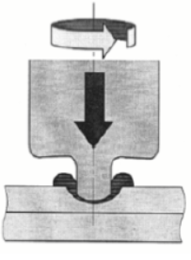

***Fig 1.1: Plunging***

**STIRRING:**

During this procedure, the tool spins through the workpiece with no further plunging. The heat

created causes the two materials in contact to melt and plasticly join.

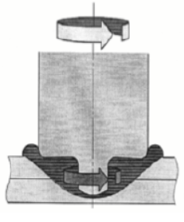

***Fig 1.2: Stirring***

**RETRACTION:**

After stirring, the tool is pulled out to its starting position during this operation, which is termed as "retraction."

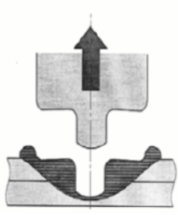

***Fig 1.3: Retracting***

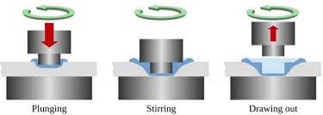

***Fig 1.4: Steps involved in friction stir spot welding***

* 1. **PROCESS PARAMETERS:**

FSSW is comprised of three critical factors that influence the effectiveness and durability of the FSSW. To accomplish a good weld, these factors must be at their optimal state. The three parameters that govern the effectiveness and durability of weld joint are:

* Tool Rotational Speed:

The tool's spinning speed is an important factor in FSSW process. The tool's output ranges from 1100 to 1900 rpm. During this technique, the non-consumable tool makes contact with work-piece at which weld joint has to be done. As the spinning tool comes into contact with work-piece, heat is generated due to friction, resulting in enhanced productivity.

As the temperature rises, the metal plasticizes, allowing the tool to puncture the workpiece and form the weld joint. The rotational speed of the tool is studied at three different rates, namely 1200, 1400, and 1600 rpm, which change based on the experiment condition. To perform an efficient weld joint, tool speed must be as fast as possible in order to generate sufficient frictional force among the workpiece and the tool.

* Plunge Depth:

Plunge depth is how deep the tool penetrates the workpiece to achieve appropriate weld joint. Understanding and determining the plunge depth is critical because it dictates the depth of the joint. The weld in FSSW occurs between two sheets. So, after the spinning tool is placed into the workpiece, the tool is plunged till it reaches half the thickness of the bottom sheet. The plunge depth must not be too low or high, as this could cause joint failure. As a result, the depth of the descent should be optimal.

* Dwell Time:

The "Dwell time" is the amount of time the tool spends in contact to the work-piece. Because the tool will be in touch with work-piece during all three operations, namely stirring, plunging, and retracting, each of these activities plays an important part in the

creation of the weldment. The weld joint usually fails if the duration is too short or too long, hence optimal dwell time must be maintained to execute a good weld.

Dwell duration determines the weld joint's effectiveness and performance.

* 1. **OBJECTIVE**

Friction stir welding (FSW) is a solid-state joining process that uses a non-consumable tool to join two facing workpieces without melting the workpiece material. Heat is generated by friction between the rotating tool and the workpiece material, which leads to a softened region near the FSW tool. While the tool is traversed along the joint line, it mechanically intermixes the two pieces of metal, and forges the hot and softened metal by the mechanical pressure, which is applied by the tool, much like joining clay, or dough. It is primarily used on wrought or extruded [aluminium](https://en.wikipedia.org/wiki/Aluminium" \o "Aluminium) and particularly for structures which need very high weld strength. FSW is capable of joining aluminium alloys, copper alloys, titanium alloys, mild steel, stainless steel and magnesium alloys. More recently, it was successfully used in welding of polymers. In addition, joining of dissimilar metals, such as [aluminium](https://en.wikipedia.org/wiki/Aluminium_joining" \o "Aluminium joining) to magnesium alloys, has been recently achieved by FSW. Application of FSW can be found in modern shipbuilding, trains, and aerospace applications

* 1. **SCOPE OF FSSW:**

Friction stir spot welding (FSSW) is a desirable form of FSW that may replace point joining procedures like resistance spot welding & riveting. Friction stir spot welding is a spot-welding process that forms a solid-state connection between two adjoining materials that overlap. Three procedures are involved in friction stir spot welding. First, the tool attached to the shaft which is rotated vertically to the work-piece. Secondly, the tool is pushed onto the top sheet's surface. The workpieces soften due to friction generation, and now the tool is fully penetrated into the work-piece till a certain depth; the tool keeps spinning and applies pressure for a certain amount of time. The tool is then retracted from the sheets. FSSW has transformed the manufacturing of components for aircraft, military, electronics, shipbuilding, and transportation, and its reach is increasing to include new sectors and applications.

* 1. **EXISTING METHOD**

**Plunge Type FSSW:** Plunge type FSSW is most commonly used in current industries. During plunge type FSSW, a rotation tool with a protruded pin is plunged into the workpieces from the top surface to a predetermined depth, and after a certain dwell time, it is retracted and a key hole is left. The frictional heat generated at the tool-workpiece interface softens the surrounding material, and the rotating and moving pin causes the material flow in both the circumferential and axial directions. The forging pressure applied by tool shoulder and mixing of the plasticized material result in the formation of a solid bond region. A schematic of plunge type FSSW method is indicated in Fig. 1.1

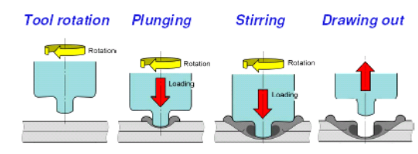

Fig. 1.5. A schematic of a plunge type FSSW

**Refill FSSW**: This patented process by GKSS involves joining multiple sheets of material by using precise movements of the pin and shoulder to fill the pin hole. It consists of three stages: initiation, full plunge, and full retract. In the initiation stage, the pin and shoulder are placed on the upper sheet and rotate to generate heat. During the full plunge stage, the shoulder is plunged into the sheet material while the pin is retracted. In the full retract stage, the shoulder is retracted and the pin is plunged to push the displaced material back into the void created by the shoulder.

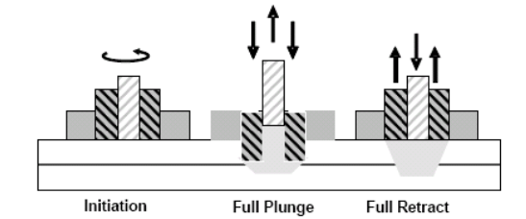

Fig. 1.6. Schematic of refill FSSW process

**Stitch FSSW**: This variation, also developed by GKSS, involves the tool moving a short linear distance after plunging before retracting. This method aims to produce joints with a larger joining area, resulting in higher strength.

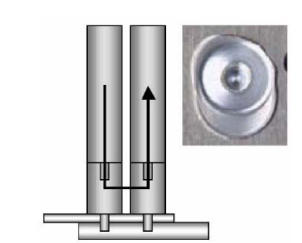

Fig. 1.7. Schematic of stitch FSSW

**Swing FSSW**: Swing FSSW was developed by Hitachi as a modification of stitch FSSW. After plunging, the tool moves up slightly and then follows a swing-like motion with a large radius and small angle. This movement causes the material to be squeezed at the end of the welding. The swing FSSW technique requires a spindle motor for tool rotation, a tool plunge motor, and a swing motor for the sliding cam that provides the swing motion.

These variations of FSSW offer different advantages and characteristics for joining materials, and each requires specific equipment and design considerations.

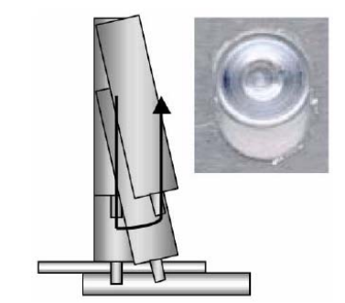

Fig. 1.8. Schematic of swing FSSW

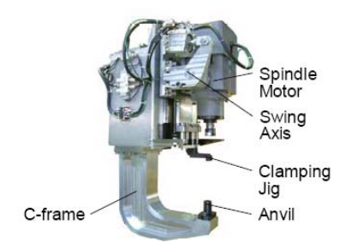

Fig. 1.9. Prototype swing FSSW gun “Swing-Stir”

**CHAPTER 2**

**LITERATURE SURVEY**

Friction welding encompasses various types, including friction stir spot welding (FSSW). Numerous studies have been conducted on FSSW using tools with and without probes. Some investigations also involved the use of tools with different profiles. This literature review summarizes the research and work conducted by various researchers and authors in the field of FSSW.

**1.**

Aluminium and copper friction stir spot welding Mingshen Li, Chaoqun Zhang, Dayong Wang, Li Zhou, Daniel Wellmann, and Yingtao Tian are among those involved. This work discusses how to efficiently combine incompatible Al and Cu materials by taking use of the metals' various characteristics. FSSW is a solid-state welding method with a promising future that can combine different metal elements. The need for these different joints has resulted in their fast manufacture. Aluminium and copper are great light weight structural materials because of their low density, high specific strength, good plasticity, and thermal and electrical conductivity. Because Al and Cu materials are used in the electrical and refrigeration sectors, their relationship is inescapable.

_____________________________________________________________________

**2.**

Effect of pin Penetration Depth on the Mechanical Properties of Friction Stir Spot Welded Aluminium and Copper, Ugar Ozdemir, Sami Sayer, Cunar Yeni, Bornova-izmir. Three alternative plunge depths for FSSW of copper and aluminium were explored in this work. The sheet thicknesses employed are 2.8mm, 4mm, and 5mm. The 2.8mm plunge depth has unsatisfactory tensile shear results when compared to the other two plunge depths, however the FSSW of the 4mm and 5mm thickness plunge depths are successful. Lower sheet penetration into top sheet was more diffuse at 4mm thickness plunge depth. Near the contact, hard and brittle intermetallic complexes of aluminium and copper developed. The tensile shear test results for 4mm and 5mm dive depths were near enough to be declared acceptable, and the lowest failure load was found for 2.8mm plunge depth.

_____________________________________________________________________

**3.**

Development of friction stir spot welding parameters for dissimilar Al5086 and C10100 spot joints, S. Siddarth*, T. Senthilkumar. The purpose of this work is to provide process activity limitIIdiagrams in the form of FSSW parameters for producing high-quality dissimilar aluminium and copper joins. Process limit diagrams of FSSW parameters such as tool rotating speed, dwell duration, and plunge depth were produced to get suitable processing areas. These parameters were developed as referenceiimaps for future designiiand technical standards for determining appropriate FSSW settings. A core composite design matrix was used to create the empirical connections between the variables. These empirical correlations help to reduce contact hardness while raising the tensile shear failure stress. Response surface approach was utilised in this study to optimise input FSSW process parameters suchIas tool rotational speed 1100 rpm, plunge depth 2.05 mm, and dwell time 11.5 seconds.

_____________________________________________________________________

**4.**

Tool geometry optimization in friction stir spot welding of Aluminium – steel joints, Joaquin M. Piccini, Hernan G. Svoboda. According to this research, the necessity to lower the weight of transportation systems such as vehicles and aeroplanes has grown increasingly important as a result of gas emission restrictions. As a result, hybrid steel-and-aluminum constructions are a potential choice for meeting this objective. This work shows friction stir spot welding of dissimilar AA5052 – LCS joints of 1 and 0.65mm thickness utilising tools constructed of common, low-cost H13 tool steel. The thickness, form, and length of the intermetallic layer are all affected by tool geometry. The "C" tool produces the thickest and most continuous intermetallic coating, measuring 5 micrometres in thickness.

_____________________________________________________________________

**5.**

Lap shear strength and fatigue lifetime of friction stir spot welded AZ31 magnesium and 5754 aluminium alloys, S.H. Chowdhury, D.L. Chen, S.D. Bhole, X. Cao, P. Wanjara. This article analyses how welding is used in the structural applications of low weight magnesium and aluminium alloys in the transportation sector. The purpose of this work was to investigate the lap shear strength and fatigue parameters of three friction stir spot welded combinations of AZ31B-H24 Mg and 5754-O Al alloys (FSSWed). The shear strength of comparable couplings, such as aluminium – aluminium and magnesium – magnesium, was larger than the shear strength of aluminium – magnesium weld junctions. In addition, the failure energy of aluminium – aluminium is larger than that of magnesium – magnesium. Furthermore, the fatigue life of identical joints Al – Al is larger than Mg – Mg, but the fatigue life of dissimilar joints is lower than that of similar joints.

_____________________________________________________________________

**CHAPTER 3**

## MATERIALS AND METHODOLOGY

* **3.1. AL6062:** ALUMINUM 6062 is a type of wrought aluminum alloy that contains magnesium silicide. This alloy exhibits favorable mechanical properties and demonstrates high resistance to corrosion from both fresh and salt water. Additionally, it is responsive to age-hardening heat treatment, which allows for further improvement of its mechanical properties.

|  |  |  |  |  |  |  |  |  |
| --- | --- | --- | --- | --- | --- | --- | --- | --- |
| Components | Mg | Si | Mn | Fe | Cu | Zn | Ti | Cr |
| Amount (wt.%) | 0.6% to 1.2% | 0.4% to 0.8% | 0.7% to 1.2% | 0.5% | 0.3% | 0.5% | 0.15% | 0.1% |

***Table3.1: AL6062 Composition***

Density: The density of AL6062 is approximately 2.7 g/cm³.

Melting point: The melting point of AL6062 is approximately 582°C to 652°C, depending on the exact composition.

Thermal conductivity: The thermal conductivity of AL6062 is approximately 200 W/m·K.

Electrical conductivity: The electrical conductivity of AL6062 is approximately 40% to 45% that of copper.

Corrosion resistance: AL6062 has good corrosion resistance, especially when compared to other aluminum alloys.

Weldability: AL6062 is considered to be highly weldable, and it can be easily joined using various welding techniques.

* **3.2. Structural steel ST1020:** The alloy steel features a hybridized finish coat comprising polysiloxane and acrylic resin, offering outstanding weather resistance, color retention, and gloss retention. This coating also exhibits excellent resistance to chemicals, solvents, and sea water, providing long-lasting protection for exposed parts.

|  |  |  |  |  |
| --- | --- | --- | --- | --- |
| Components | C | Mn | P | S |
| Amount (wt.%) | 0.17% to 0.23% | 0.30% to 0.60% | 0.04% | 0.05% |

***Table3.2: Structural steel ST1020* *Composition***

Density: The density of ST1020 is approximately 7.85 g/cm³.

Melting point: The melting point of ST1020 is approximately 1420°C to 1460°C.

Tensile strength: The tensile strength of ST1020 is approximately 420 MPa.

Yield strength: The yield strength of ST1020 is approximately 350 MPa.

Modulus of elasticity: The modulus of elasticity of ST1020 is approximately 200 GPa.

Elongation: The elongation of ST1020 is approximately 15% to 20%.

* **3.3. D3 steel Tool Material:** D3 steel is a type of tool steel that is air hardening and contains high levels of carbon and chromium. It is known for its remarkable resistance to abrasion and wear, as well as its ability to maintain dimensional stability. Additionally, D3 steel exhibits high compressive strength. It can be heat treated to achieve a hardness between 58 and 64 HRC.

|  |  |  |  |  |  |  |  |  |  |  |
| --- | --- | --- | --- | --- | --- | --- | --- | --- | --- | --- |
| Components | C | Mn | Si | Cr | Ni | W | V | P | S | Cu |
| Amount  (wt.%) | 2.00-  2.35 | 0.60 | 0.60 | 11.00–13.50 | 0.30 | 1.00 | 1.00 | 0.03 | 0.03 | 0.25 |

***Table3.3: D3 Steel Composition***

Density: The density of D3 steel is approximately 7.7 g/cm³.

Melting point: The melting point of D3 steel is approximately 1425°C to 1515°C.

Hardness: D3 steel has a high hardness of approximately 58 HRC when heat-treated.

Toughness: D3 steel has moderate toughness, which makes it suitable for applications that

require good wear resistance and high hardness.

Wear resistance: D3 steel has excellent wear resistance due to its high chromium content.

Machinability: D3 steel has good machinability in the annealed condition, but it can

become more difficult to machine after heat treatment.

The tool tip has a hexagonal profile and is made of D3 steel, which has been heat treated at a temperature above its recrystallization point to achieve high strength. Figure 1.6 shows the structure of the tool, along with a lap configuration diagram. During the welding process, the aluminum material is positioned on top, while the steel material is placed at the bottom of the lap joint. The resulting welded joint is then subjected to testing using an automated universal testing machine with a capacity of 40 kN. Various thicknesses of 0.5mm, 0.7mm, 0.9mm, as well as combinations of these thicknesses, were used for the testing. The material has been cut into pieces measuring 150 mm in length and 20 mm in width.

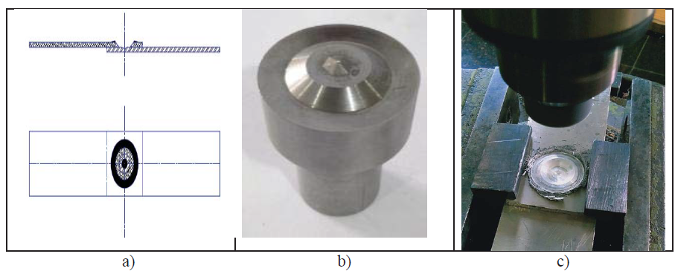

Fig. 1.6**.** (a) Lap position of work material, (b) FSSW tool geometry, (c) Setup on machine with fixture

* **3.4. METHODOLOGY:**

The current work is concerned with FSSW of aluminum and steel. The dimensions of both materials were 140*50, with thicknesses ranging from 1.5mm to 3mm. The lap junction is formed by connecting the bottom of the aluminium sheet to the top of the steel sheet. The lap joint is 50mm long, as seen in fig. The FSSW machine was utilized in the test. The mixing head used is composed of D3 tool steel and has a 30mm shoulder diameter. The mixing needle is 1mm in length and 2mm in diameter.

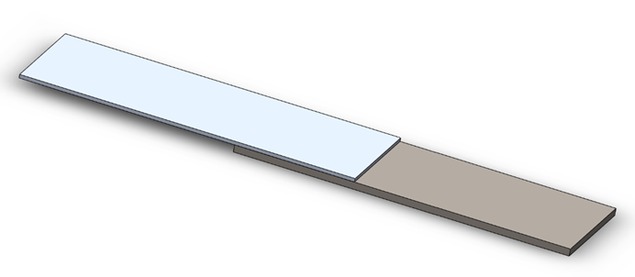

***Fig 3.4: Lap joint of AL6062 and ST1020***

* **3.5.** **WELDING METHOD:**

Aluminum and steel components are cleaned with acetone prior to the weldment to eliminate dust and oily particles. The rotating tool was progressively pulled down during welding until its end comes inicontact with the top surface ofithe aluminium sheet. The tool was pushed into the work-piece materials by applying force to it. The spinning tool was kept for a time frame called as Dwell time after reaching a specific depth. The tool was then withdrawn to its original position, and the welding was completed.

To improve process variables such as rotation speed, dwell duration, and plunge depth, the Taguchi test methodology was employed. Following welding, the shear stress of all samples was tested using a universal testing equipment, and average results were collected.

* **3.6. PROCESS PARAMETER**

Stirring friction stop welding involves complex material movement and plastic deformation. A few major factors that affect the friction stir welding process are properly considered within that section, such as geometrical parameters, tool rotational speed, welding speed and applied load. Welding parameters such as geometrical parameters, tool circular motion, welding speed, applied load and joint size have a major effect on the welding properties. The base metal is greatly altered in friction swirl spot welding due to the high temperature and extreme plastic deformation during the process. The metallurgical relation at the weld joint and the annular bond area defines the mechanical properties of welded steel joints at the friction stir spot. Tool Penetration Depth in mm, Tool rotation rate in rpm, Tool shoulder dip depth in mm, Length of the dip in seconds, Tool dip speed in mm / min, Axial force of the tool rotating in N. To overcome different possibilities of failure a lower the defects in the process of joint in stir spot welding optimization makes a good impact to find the good series of best parameter sequence

**CHAPTER 4**

**DESIGN AND ANALYSIS**

**4.1.TOOL DESIGN:**

According to the measurements, the tool was created in "SOLIDWORKS 2021." Dassault Systems introduced it in 1995 as a computer-aided design application that runs on A Computer and includes 3D apps. Using Computer Aided Engineering, this application is used to produce models and assemblies. It has a powerful capacity of designing components, surfaces, sheet metal, and so on, as well as the ability to combine the parts and create engineering drawings utilizing the planned 3D model. For the design of experiments, the "MINI TAB" software is employed. The use of "ANOVA" is used to validate findings for bigger the better.

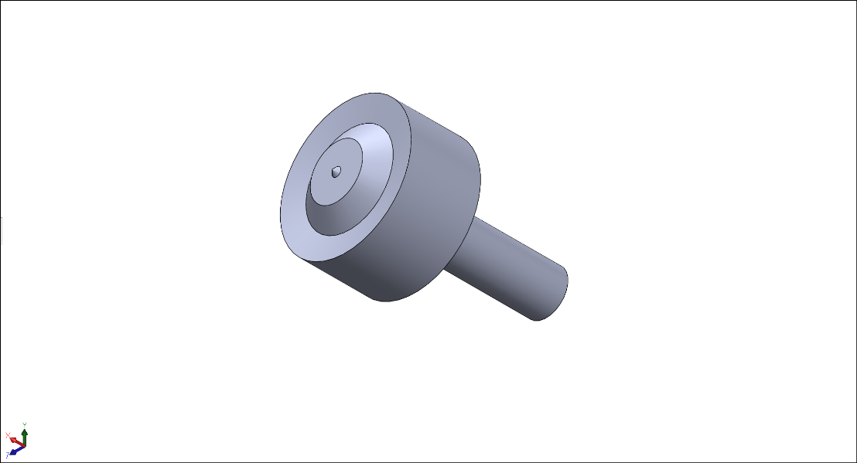

***Fig 4.1: Tool design in SOLIDWORKS 2021***

**4.2. HEAT TREATMENT**

Heat treatment isiithe procedure of heatingiimetal without letting itiito reach a liquid metal state, and then cooling it in a regulated manner to choose desirable physical and mechanical qualities. Heat treatment isiithe procedure of heatingimetal without letting itito melt and then cooling in a regulated way to choose desired properties and physical qualities. Metal quenching, metal hardening, metal tempering, metallurgical furnace, and tool hardening are all heat treatment techniques.

The metal hardening procedure was used to increase the hardness levels and enhance the mechanical characteristics of the material. Metal quenching is a procedure that involves heating the material to the desired temperature and then quenching it in water or oil to harden it. Metal tampering is used to provide the necessary combinations for hardness, strength, and toughness. The metallurgical furnace is a study where the D3 material is utilized to create a tool with a machinability rate of about 75% for chromium hot-work steel. The D3 tool, which is constructed of steel, is hardened in the furnace at 900 for three hours.

**Muffle Furnace:**

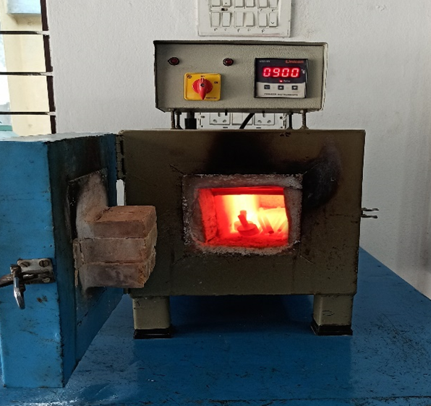

***Fig 4.2: Muffle Furnace***

**Specifications:**

|  |  |
| --- | --- |
| **Voltage** | **: 440V** |
| **Temperature** | **: 1220 ºC** |
| **Insulation** | **: Cement** |
| **Volume** | **: 4896 cm3** |

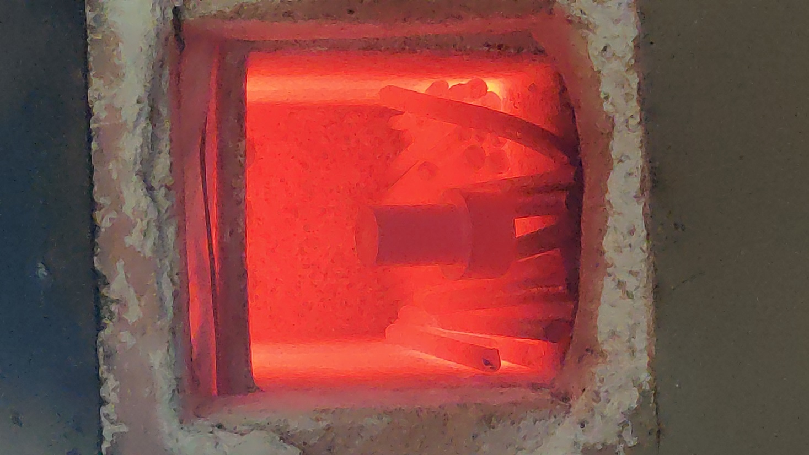

***Fig 4.3: Tool under Heat Treatment***

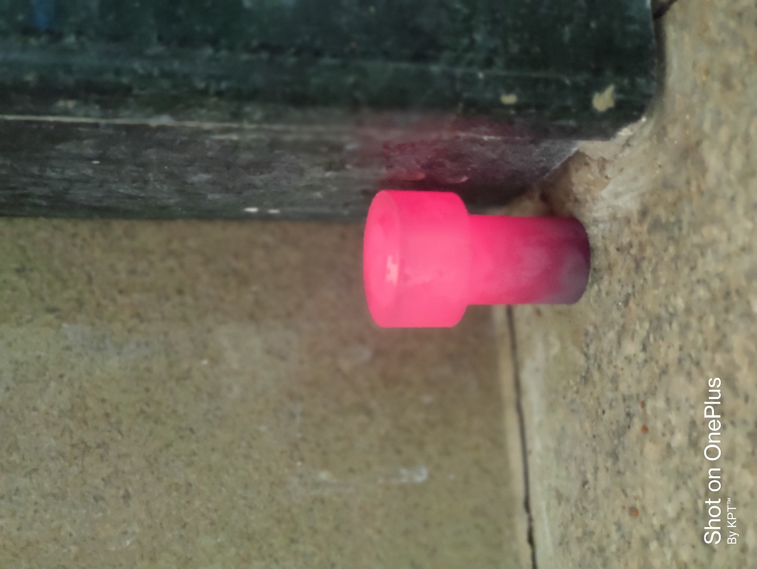

***Fig 4.4: Gradual cooling in room temperature***

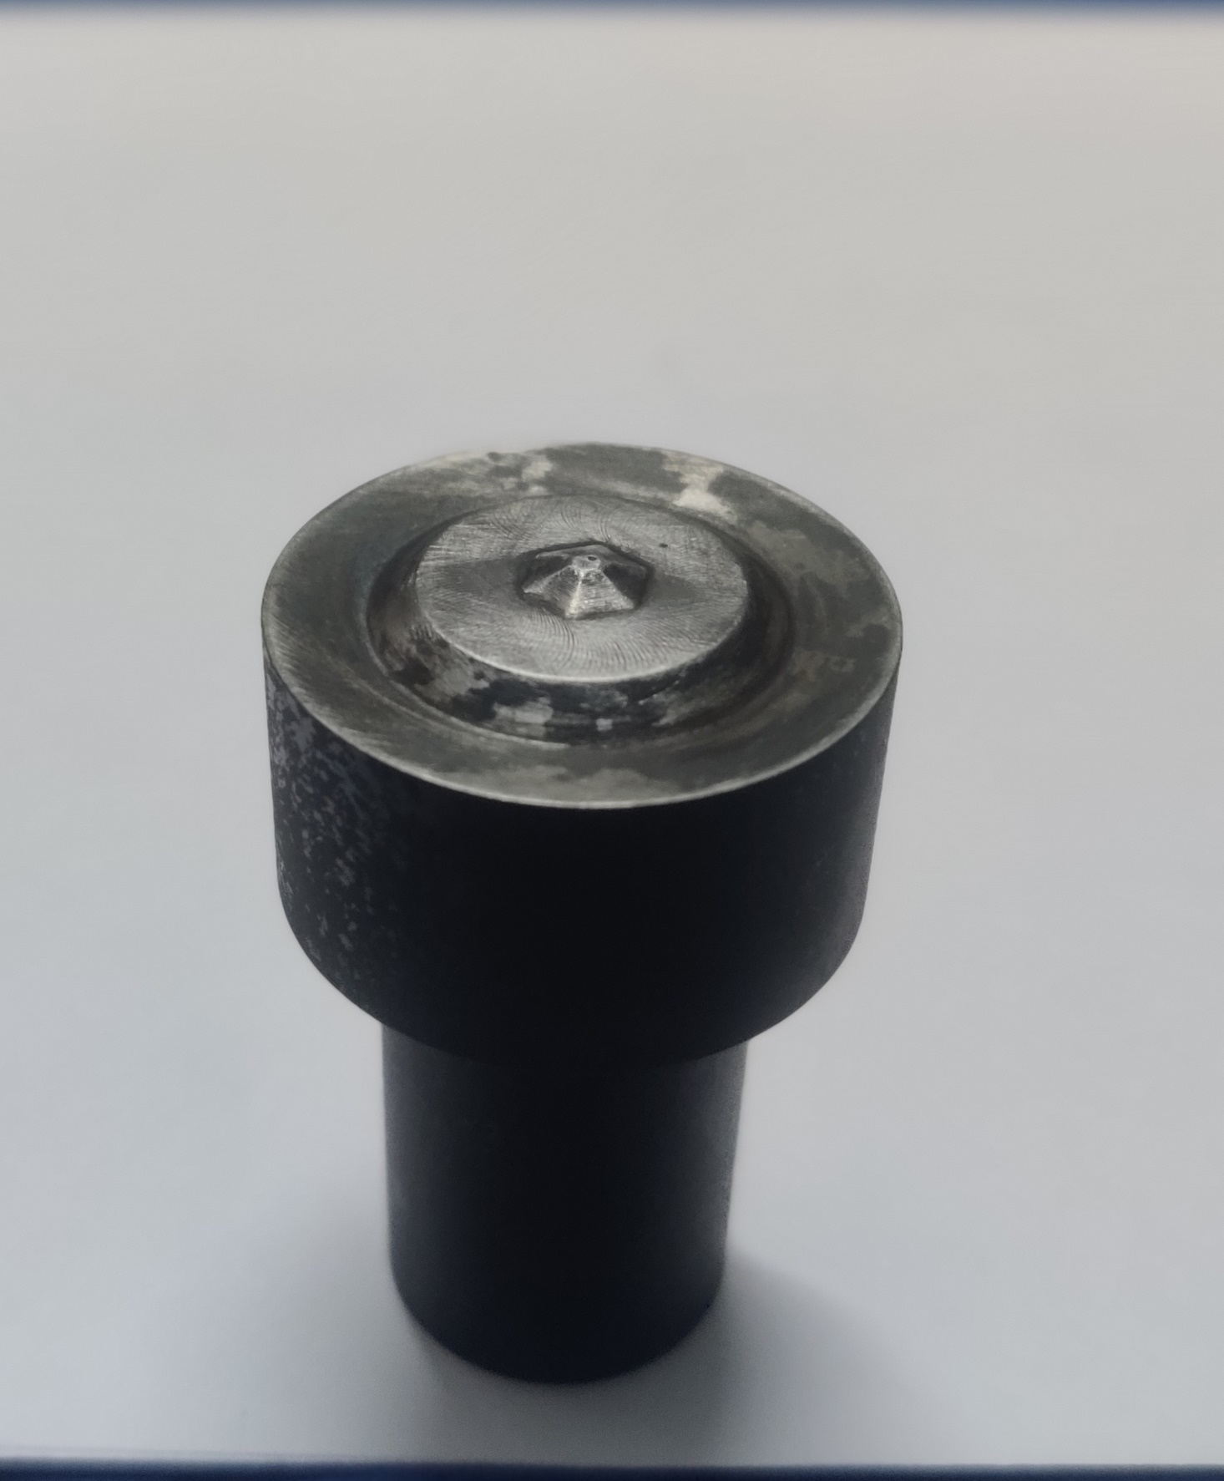

***Fig 4.5: Tool after Heat Treatment***

**CHAPTER 5**

**EXPERIMENTAL SETUP**

AL6062 and ST1020 work materials with varied thicknesses of 1.5mm and 3mm AND dimensions of 120 mm length and 50 mm width were employed. The AL6062 and ST1020 plates are lapped in the vice of the FSSW machine, with the AL6062 on top and the ST1020. To achieve high strength, the tool is "D3" with a conical pin shape at the end. After the weld connection is completed, the welded experiment is tested in the Automatic universal testing machine to determine the strength of the weld joint.

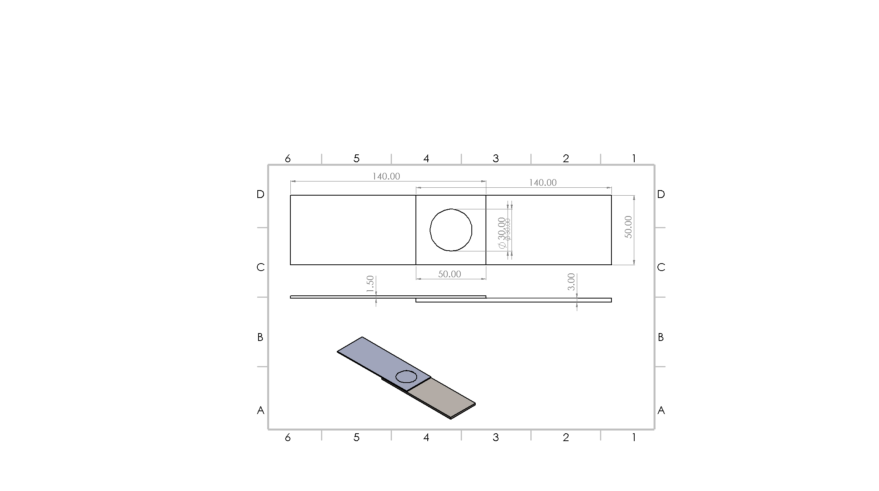

***Fig 5.1: Lap positioning of AL6062 and ST1020***

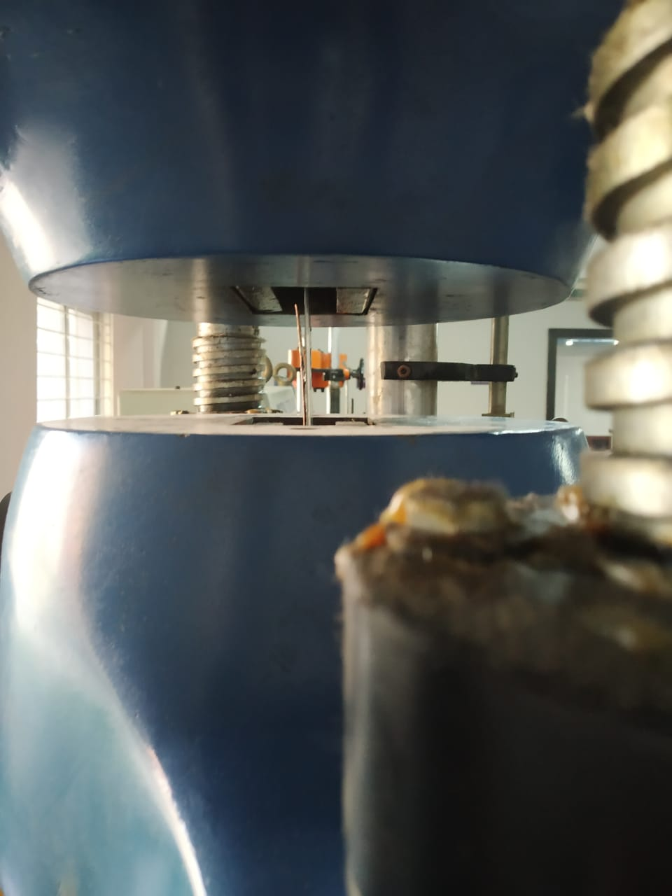

***Fig 5.2: Work-piece loaded in UTM***

**DESIGN OF EXPERIMENT**

The technique of friction stir spot welding includes very intricate material movement as well as massive plastic deformation. There are a few important aspects that must be properly addressed in order to affect the friction stir spot welding process, such as geometrical characteristics such as tool rotating speed, welding speed, and load applied. Other welding characteristics, such as tool circular motion, weld speed, tool load, and joint size, have a significant impact on the welding qualities. The intense heat and plastic deformation would simply induce a significant change in the base metal throughout the welding operation. The metal's mechanical characteristics are dictated by the weld joint and the annular bond regions. The tool's penetration depth is specified in millimeters, its rotating rate is specified in revolutions per minute, the length of the dip is specified in seconds, and the tool's dip speed is specified in millimeters per minute. The axial force of the tool is specified in KN, which is simply to overcome the possibility of failure while also reducing the possibility of flaws.

To improve process variables such as rotation speed, dwell duration, and plunge depth, the Taguchi test methodology was employed.

**Parameter and Levels**

|  |  |  |
| --- | --- | --- |
| **Tool Rotational Speed (RPM)** | **Dwell Duration (sec)** | **Plunge Depth (mm)** |
| 1200 | 24 | 3.8 |
| 1400 | 26 | 3.9 |
| 1600 | 28 | 4 |

***Table 5.1: 3 Parameters* x *3 Levels***

L9 Orthogonal Array is used to define the number of experiments to be done for 3 factors x 3 levels. This method is used for its effectiveness with a smaller number of experiments.

**L9 Model of Orthogonal Array**

|  |  |  |
| --- | --- | --- |
| **Tool Rotational Speed (RPM)** | **Dwell Duration (sec)** | **Plunge Depth (mm)** |
| 1200 | 24 | 3.8 |
| 1200 | 26 | 3.9 |
| 1200 | 28 | 4 |
| 1400 | 24 | 3.9 |
| 1400 | 26 | 4 |
| 1400 | 28 | 3.8 |
| 1600 | 24 | 4 |
| 1600 | 26 | 3.8 |
| 1600 | 28 | 3.9 |

***Table 5.2: L9 Orthogonal***

**CHAPTER 6**

**RESULT AND DISCUSSION**

The optimal values for tool rotational speed, dwell duration and plunge depth are obtained by analyzing the Taguchi method and performing ANOVA.

**Response Table for UTM and Sig/Noise ratios:**

|  |  |  |  |  |
| --- | --- | --- | --- | --- |
| **Tool Rotational Speed (RPM)** | **Dwell Duration (sec)** | **Plunge Depth (mm)** | **Tensile Strength (kN)** | **S/N Ratio** |
| **1200** | **24** | **3.8** | **4.2** | **12.4650** |
| **1200** | **26** | **3.9** | **4.6** | **13.2552** |
| **1200** | **28** | **4** | **3.9** | **11.8213** |
| **1400** | **24** | **3.9** | **5** | **13.9794** |
| **1400** | **26** | **4** | **3.6** | **11.1261** |
| **1400** | **28** | **3.8** | **4.1** | **12.2557** |
| **1600** | **24** | **4** | **4.3** | **12.6694** |
| **1600** | **26** | **3.8** | **3.8** | **11.5957** |
| **1600** | **28** | **3.9** | **4** | **12.0412** |

***Table 6.1: UTM results and S/N ratios***

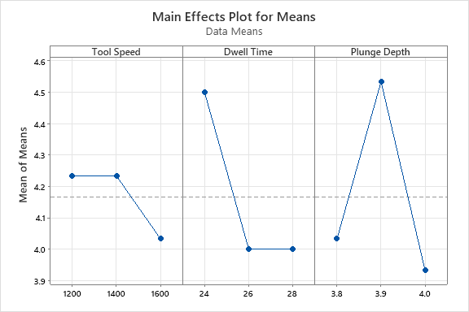

***Fig 6.1: Graph of Effects plot for Means***

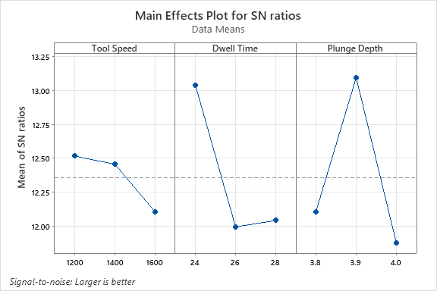

***Fig 6.2: Graph of Effects plot for S.N ratios***

|  |  |  |  |
| --- | --- | --- | --- |
| **Level** | **Tool Speed** | **Dwell Time** | **Plunge Depth** |
| **1** | 12.51 | 13.04 | 12.11 |
| **2** | 12.45 | 11.99 | 13.09 |
| **3** | 12.10 | 12.04 | 11.87 |
| **Delta** | 0.41 | 1.05 | 1.22 |
| **Rank** | 3 | 2 | 1 |

***Table 6.2: Response Table for Signal to Noise Ratios***

|  |  |  |  |
| --- | --- | --- | --- |
| **Level** | **Tool Speed** | **Dwell Time** | **Plunge Depth** |
| 1 | 4.233 | 4.500 | 4.033 |
| 2 | 4.233 | 4.000 | 4.533 |
| 3 | 4.033 | 4.000 | 3.933 |
| Delta | 0.200 | 0.500 | 0.600 |
| Rank | 3 | 2 | 1 |

***Table 6.3: Response Table for Means***

We can observe that Plunge depth is having most significant impact on the results than Dwell duration and Tool rotational speed

|  |  |
| --- | --- |
| **Parameter** | **Rank** |
| Plunge Depth | 1 |
| Dwell Duration | 2 |
| Tool Rotational Speed | 3 |

***Table 6.4: Parameter ranking***

**Regression Analysis:**

**Regression Equation:**

Tensile Strength = 10.07 - 0.000500 Tool Speed - 0.1250 Dwell Time - 0.50 Plunge Depth

**Analysis of Variance:**

|  |  |  |  |  |  |
| --- | --- | --- | --- | --- | --- |
| **Source** | **DF** | **Adj SS** | **Adj MS** | **F-Value** | **P-Value** |
| **Tool Speed** | 1 | 0.06 | 0.06 | 0.3 | 0.609 |
| **Dwell Time** | 1 | 0.375 | 0.375 | 1.86 | 0.231 |
| **Plunge Depth** | 1 | 0.015 | 0.015 | 0.07 | 0.796 |
| **Error** | 5 | 1.01 | 0.202 |  |  |
| **Total** | 8 | 1.46 |  |  |  |

***Table 6.5: ANOVA for sources***

**Response Optimization:**

**Variable Ranges:**

|  |  |
| --- | --- |
| **Variable** | **Values** |
| Tool Speed | [1200, 1600] |
| Dwell Time | [24, 28] |
| Plunge Depth | [3.8, 4] |

***Table 6.6: Ranges of Values for Variables***

**Optimized Response Solution: Tensile Strength**

|  |  |  |  |
| --- | --- | --- | --- |
| **Tool Rotational Speed** | **Dwell Duration** | **Plunge Depth** | **Tensile Strength Fit** |
| 1200 | 24 | 3.8 | 4.5667 |

***Table 6.7: Optimal Solution from the performed values***

**CHAPTER - 7**

**CONCLUSION**

We did Friction Stir Spot Welding of two dissimilar metals, AL6062 and ST1020, of various thicknesses, say 1.5mm and 3mm, in this project, and the results are shown. To unite these metals, a tool composed of D3 tool steel is utilized. Three factors for metal joining are selected at three separate levels: tool speed, dwell duration, and plunge depth. Friction Stir Spot Welding was done on an FSSW machine, and the values were computed and studied thoroughly. To verify the generated joint utilizing the welding technique, design of experiments is used; ANOVA is done for larger the better value. The Taguchi Method was utilized to optimize the FrictionIStirISpotJWelding process parameters. The following graphs were created using the Minitab software: Main effects plots for means and SN ratios have been produced, and the following tables have been obtained: response table for signalItoInoise ratio, response table for means, and response table for SNRA1. As a consequence, there is a fact that demonstrates that using these would result in an enhancement as well as a solution for the advancement in the future.

Friction Stir Spot Welding (FSSW) was used to join Aluminium 6062 and ST1020. The joint was tested in a Universal Testing Machine (UTM), and tensile results were obtained. To minimize the number of experiments, Taguchi's technique was employed. An orthogonal array was selected for this purpose. The objective was to maximize the tensile strength obtained in Minitab, using the signal-to-noise ratio (S/N) and variance analysis (ANOVA) to optimize the FSSW parameters. The results indicated that the rotational speed of the tool (RPM) and plunge depth had a significant influence on the tensile strength of the welded joints, among other key welding parameters. The ANOVA analysis revealed that the rotational speed of the tool was the most significant factor affecting the welding process.

**CHAPTER - 8**

**APPLICATIONS**

1- Aerospace industry: FSSW is also used in the aerospace industry for joining lightweight materials used in aircraft manufacturing, such as aluminum, titanium, and composites.

2- Shipbuilding industry: FSSW is used to join the hull and deck plates of ships. This process produces high-quality welds, ensuring the safety and reliability of the ship.

3- Rail industry: FSSW is used to join railway carriages and high-speed trains. It is particularly useful in reducing the weight of trains, improving their fuel efficiency, and reducing maintenance costs.

4- Friction stir welding is applicable in the electrical industry for creating electrical connectors and electric motor housings.

5- Certain alloys that can be welded using friction stir welding find application in the construction and chemical industries, including aluminum reactors for power plants.

6- Friction stir welding is suitable for joining high-strength alloys that can be utilized as armor materials.

7- Friction stir welding joints are used in land transportation for various purposes such as automotive engine chassis, truck bodies, and wheel rims.

8- FSW is employed in the aerospace industry for joining lightweight aluminum frames in aircraft fuselages. It provides a lighter alternative to traditional methods like bolting or riveting.

9- Friction stir welding is utilized in the railroad industry for manufacturing high-speed trains, specifically for joining hollow profiles and T-stiffener extrusions.

10- In the automotive industry, friction stir welding is commonly used to join lightweight materials like aluminum and magnesium. It is employed in the assembly of body panels, hoods, doors, and other automotive components.

**REFERENCES**

1. C. Labesh Kumar, G. Bharathiraja, and V. Jayakumar Friction stir spot welding of Al6062/St1020 metals with dissimilar thicknesses, Cite as: AIP Conference Proceedings 2317, 020036 (2021); <https://doi.org/10.1063/5.0036200> Published Online: 05 February 2022.
2. S.Siddharth, T . Senthil kumar” Development of friction stir spot welding windows for dissimilar Al5086/C10100 spot joints” Materials Today: Proceedings 5 (2018) 6550–6559.
3. Mukuna P. Mubiayi, and Esther T. Akinlabi, “Friction Stir Spot Welding of Dissimilar Materials: An Overview”, Proceedings of the World Congress on Engineering and Computer Science 2014 Vol II WCECS 2014, 22-24 October, 2014, San Francisco, USA.
4. G.K Padhy, C.S Wu, S.Gao , “Friction stir based welding and processing Technologies processes, parameters, Microstructures and applications: A review”, Journal of Material Sci. and Technol. 34 (2018) 1-38.
5. S. Joy-A-Ka, Y. Ogawa, A. Sugeta, Y.F. Sun and H. Fujii, “Fatigue Fracture Mechanism on Friction Stir Spot Welded Joints Using 300 MPa-Class Automobile Steel Sheets under Constant and Variable Force Amplitude”, Procedia Materials Science 3 (2014) 537–543.
6. F.C. Liu, Y. Hovanski, M.P. Miles, C.D. Sorensen, T.W. Nelson, “A review of friction stir welding of steels: Tool, material flow, microstructure, and properties”, Journal of Material Sci. and Technol. 34 (2018) 39-57.
7. Gianluca Buffa, PierluigiFanelli, LivanFratini, Francesco Vivio, “Influence of joint geometry on micro and macro mechanical properties of friction stir spot welded joints”, Procedia Engineering 81 (2014) 2086 – 2091.
8. Mukuna P. Mubiayi and Esther T. Akinlabi, “An Overview on Friction Stir Spot Welding of Dissimilar Materials”, DOI: 10.1007/978-94-017-7236-5_38.
9. S. Siddharth, T. Senthilkumar, “Study of tool penetration behaviour in Dissimilar Al5083/C10100 friction stir spot welds”, Procedia Engineering 173 (2017) 1439 – 1446.
10. M. Santella, Y. Hovanski, A. Frederick, G. Grant, M. Dahl – “Friction stir spot welding of DP780 carbon steel”- Sci. Technol. Weld. Join. 15 (2010)271–278.
11. Labesh Kumar, C., Jayakumar, V., Bharathiraja, G. “Optimization of welding parameters for friction stir spot welding of AA6062 with similar and dissimilar thicknesses” Materials Today proceedings Elsevier Volume 19,Part 2, 2019, Pages 251-255.

“